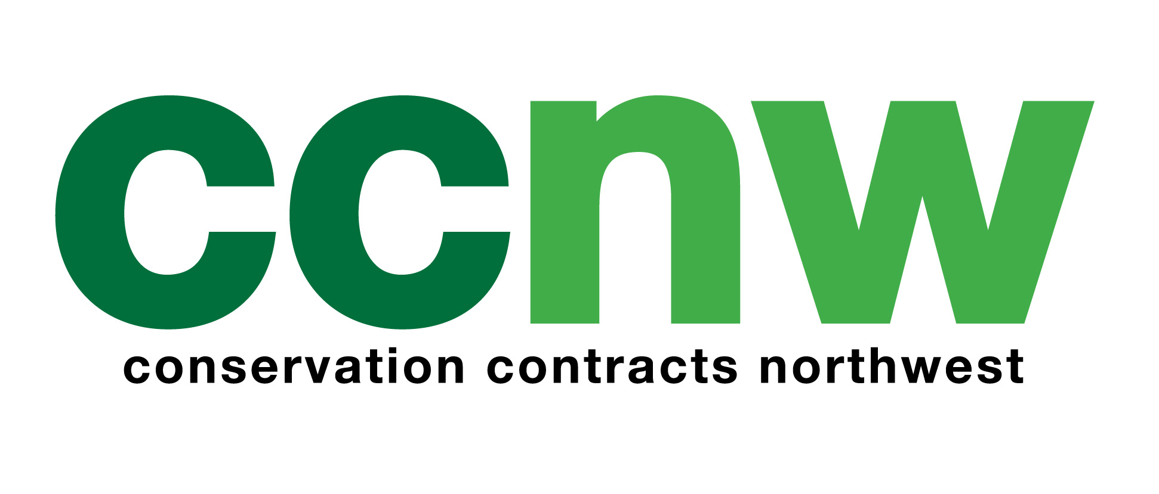

CCNW – Role Specification
Role: Plant and Machinery Operative
Company: Conservation Contracts North West Ltd
Salary: POA
Location: Throughout the North West of England
Website: www.ccnw.info

About Us
Conservation Contracts North West Ltd (CCNW), based in Horwich, is a professional environmental contracting and consultancy business specialising in habitat management and environmentally and ecologically sensitive projects across the north of England, with additional project work undertaken further afield.
We provide an integrated and comprehensive service to local authorities, government agencies, commercial clients, community groups, utility companies and landowners, working in partnership to enhance and protect the natural environment.
An opportunity has arisen for an experienced Plant and Machinery Operative to join and strengthen our established and experienced operational teams.

Role Responsibilities
The successful candidate will be responsible for the day-to-day delivery of practical works across a range of conservation sites. Key responsibilities include:
- Undertaking maintenance and landscaping works on sites throughout the North West of England
- Operating mobile plant, including 360-degree excavators and dumpers, to support the delivery of conservation projects
- Carrying out rural groundwork, including both hard and soft landscaping
- Maintaining, rebuilding and installing public rights of way and bridleways
- Delivering pond, river and wetland creation works, along with ongoing maintenance and anti-erosion measures
- Taking responsibility for CCNW’s local resources, including premises, vehicles, plant, equipment, tools, materials, PPE and uniform, ensuring they are maintained, serviced and replaced as required
- Ensuring all practical works are undertaken in full compliance with health and safety procedures and company policies
- Assisting the Operations Manager in communicating company policies, practices and procedures to junior staff
- Representing CCNW in a professional and responsible manner at all times, including when wearing company-branded uniform and PPE, using company vehicles, and communicating via company telephones and email accounts
- Demonstrating flexibility and a proactive, ‘can-do’ attitude, undertaking any other reasonable duties required to fulfil the role and support the achievement of CCNW’s objectives, as directed by the Operations Manager
An active interest in the outdoor environment is essential. Experience and competence in operating mobile plant across a range of habitats, including wetlands and peat bogs, would be desirable.

Experience and Qualifications
Applicants must be able to demonstrate:
- Previous operational experience using 360-degree excavators (1.5–22 tonnes) and wheeled and tracked dumpers
- A valid CSCS, NPORS or equivalent card (minimum requirement: 360 excavator up to 10 tonnes)
- A full UK driving licence, access to private transport, and the ability to tow trailers (Category B+E)
- A practical conservation background or a relevant qualification in conservation, countryside management or environmental studies (desirable but not essential)
- A willingness to undertake training on additional machinery as required

What We Offer
- Competitive starting salary, dependent on qualifications and experience
- 29 days’ annual leave, including Bank Holidays
- A comprehensive training package
- A supportive and collaborative working environment
- Company uniform and PPE

Applications
To apply, please visit our website at www.ccnw.info and complete the application form. Completed application forms, along with a CV and covering letter, should be emailed to gl@ccnw.info or posted to:
Personnel Department
Conservation Contracts North West Ltd
29–31 Lee Lane
Horwich
Bolton
BL6 7AX
conservation contracts north west limited
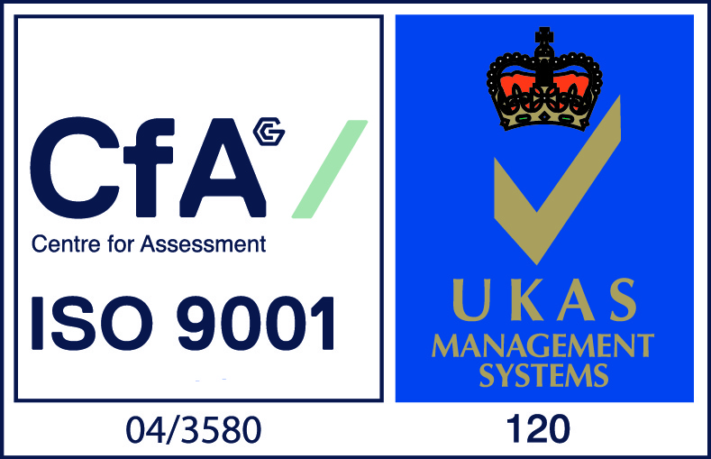

29-31 lee lane horwich bolton bl6 7ax
telephone: 01204 693500 fax: 01204 693503
e: contact@ccnw.info w: www.ccnw.info

