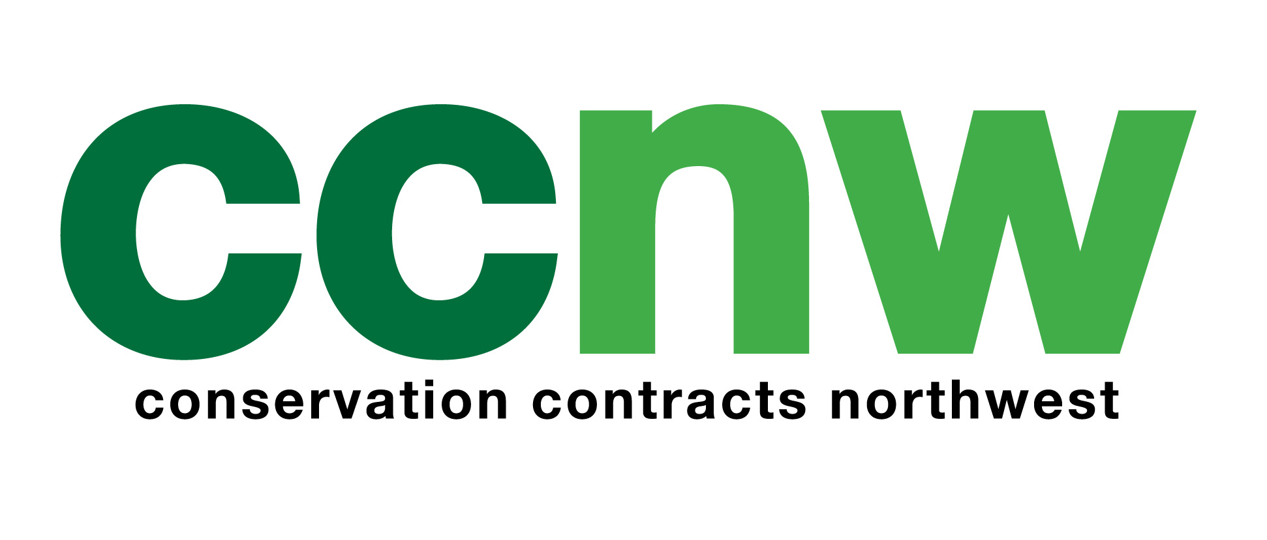

CCNW – Role Specification
Role: Conservation Project Supervisor
Company: Conservation Contracts North West Ltd
Salary: POA
Location: Horwich, Bolton, with projects across the North West
Website: www.ccnw.info
Contact Email: je@ccnw.info

About Us
Conservation Contracts North West Ltd (CCNW) is a professional environmental contracting and consultancy organisation specialising in habitat management and the delivery of environmentally sensitive projects across the North West of England.
As part of our continued business growth, we are seeking to appoint a Conservation Project Supervisor to strengthen our experienced operational team.
We provide an integrated and comprehensive service to local authorities, government agencies, commercial clients, community groups, utility companies and landowners, working collaboratively to protect and enhance the natural environment.

Role Responsibilities
The Conservation Project Supervisor will be responsible for the supervision and delivery of practical conservation works across a range of sites. Key responsibilities include:
- Supervising and working alongside a small team to deliver medium to large-scale practical environmental conservation programmes across the North West
- Liaising with clients to ensure the successful delivery of high-quality conservation projects that contribute to targets set out in the CCNW Strategic Plan and Local Operational Plans
- Managing CCNW’s local resources, including premises, vehicles, protective clothing, tools and material stocks, ensuring they are maintained, serviced and replaced as necessary
- Completing and taking responsibility for all site-specific risk assessments, while ensuring generic risk assessments are followed at all times
- Ensuring all practical works are delivered to a high standard and in full compliance with health and safety policies and procedures
- Undertaking any other reasonable duties required to fulfil the role and to support the management team in achieving CCNW’s objectives

Post Requirements
Applicants should be able to demonstrate:
- A practical or relevant qualification in conservation, countryside management or environmental practices, or equivalent up-to-date practical experience
- Proven ability to lead and motivate a team across a wide range of conservation projects
- A genuine and active interest in the outdoor environment
- A full UK driving licence and access to private transport
- The ability to ensure projects are completed to specification and within agreed timescales

What We Offer
- Competitive starting salary, dependent on qualifications and experience
- Company vehicle (for work use only, unless otherwise specified)
- 29 days’ annual leave
- Ongoing staff support and training
- Company uniform

Applications
To apply, please visit our website at www.ccnw.info and complete the application form. Completed application forms, along with a CV and covering letter, should be emailed to gl@ccnw.info or posted to:
Personnel Department
Conservation Contracts North West Ltd
29–31 Lee Lane
Horwich
Bolton
BL6 7AX
conservation contracts north west limited
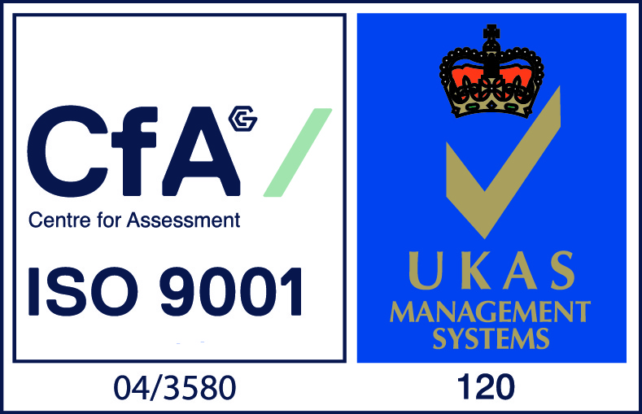

29-31 lee lane horwich bolton bl6 7ax
telephone: 01204 693500 fax: 01204 693503
e: contact@ccnw.info w: www.ccnw.info

